**FUSION ENHANCEMENT OF UNDERWATER IMAGES**

**CHAITANYA THAPLIYAL, AMITOJ BIRAH, UTKARSH SINGHAL, DIPENDER SINGH**

*Student, Computer Science Engineering, Amity School of Engineering and Technology Noida, India*

*Student, Computer Science Engineering, Amity School of Engineering and Technology Noida, India*

*Student, Computer Science Engineering, Amity School of Engineering and Technology Noida, India*

*Student, Computer Science Engineering, Amity School of Engineering and Technology Noida, India*

*Email:* [*cthapliyalbs@gmail.com*](mailto:cthapliyalbs@gmail.com)*. ,* [*amitojbirah1@gmail.com*](mailto:amitojbirah1@gmail.com)*,* [*u.singhalskd@gmail.com*](mailto:u.singhalskd@gail.com), [*deepandera1@gmail.com*](mailto:deepandera1@gmail.com)

***Abstract***

*This research paper suggests a strategy for improving underwater images by combining various image processing approaches. The suggested approach efficiently extracts important data from several underwater images using the Discrete Wavelet Transform (DWT) image fusion methodology. A low-quality underwater image is chosen, preprocessed with CLAHE contrast correction and gamma correction for illumination removal, and then dehazed using a CNN-based algorithm. The preprocessed photos are then combined using the DWT method to get the improved image. Compared to the CNN-based method, the suggested methodology is computationally cheap and utilizes fewer resources. PSNR, SSIM, and CCF are only of the analytical techniques used to assess the performance of the suggested methodology. The outcomes show that by keeping both high-frequency and low-frequency information while reducing noise and artifacts, the suggested strategy is excellent at enhancing underwater images.*

***Keywords-*** *DWT, DCT, wavelet, CNN, Laplacian pyramid, Gaussian pyramid, PSNR, SSIM, MSE, CFF*

1. **INTRODUCTION**

Due to color cast and low visibility in underwater photographs, which are brought on by absorption and medium scattering, it is necessary to combine many underwater images in order to effectively extract the crucial information from them. Fusion-based underwater picture enhancing techniques have become a possible solution to these problems.

The Discrete Wavelet model based on the Laplacian method is proposed in this paper to simulate the degraded course. The degraded image is considered to be the approximation signal of the pyramid decomposition, and the reformation work of the resulting image is that of the Laplacian with no interference from the detailed photo.

The DWT-based fusion method's capacity to handle the multi-resolution nature of underwater images is one of the factors contributing to its exceptional performance. The DWT-based technique provides for the better retention of both high-frequency and low-frequency information since it can divide an image into numerous sub-bands at various resolutions. The DCT-based approach and the CNN-based method, in contrast, do not have this multi-resolution capability, which results in the loss of significant data. Additionally, compared to the CNN-based method, that's computationally costly because of its deep learning architecture, the DWT-based fusion technique is computationally inexpensive and uses fewer resources.

In this paper two instances of image are taken and then the contrast is corrected for the first instance of image using CLAHE algorithm. The Illumination is removed from the contrast enhanced image using Gamma Correction, the second instance of image is dehazed using the Convolutional neural network and both of the instances are fused together using a Discrete Wavelet model to get an enhanced underwater image.

1. **METHODOLOGY**

This paper includes Discrete Wavelet Transforms (DWT) technique for image enhancement to enhance the images of the dataset consisting of 890 underwater images

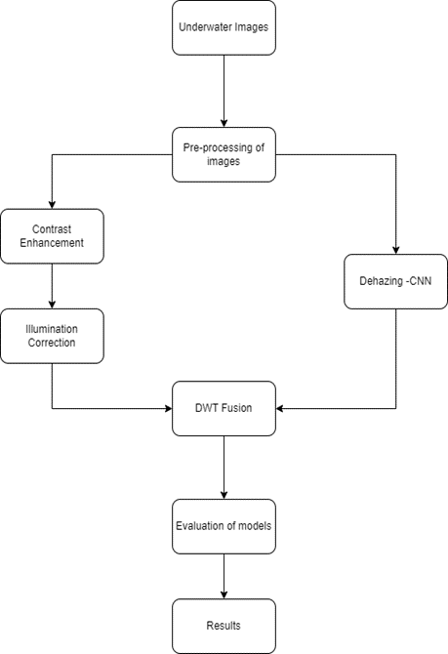

**Fig 1: Flow diagram of working of the project**

Choosing a low-quality underwater image with a variety of objects, settings, and illumination is the first stage. The water in the photograph should be in a variety of states, including clear, muddy, and murky. The image is then subjected to preprocessing, beginning with the CLAHE contrast correction to enhance the image's contrast. The CLAHE algorithm is utilized because it enhances the details in dark areas and adjusts to the local contrast of the image.

After that, gamma correction is utilized to eliminate the uneven lighting brought on by light scattering and absorption in water. Gamma adjustment enhances overall contrast and modifies image brightness.

The haze is then removed from the image and the visibility is improved using the dehazing approach utilizing a CNN. CNN-based dehazing technology is utilized because it can generate a haze-free image while maintaining the colour and contrast information by learning the intricate link between the input and output images.

The enhanced image is then created by fusing together the resultant images from the contrast correction, illumination removal, and dehazing processes in preprocessing using the DWT approach. The DWT decomposes the preprocessed images into sub-bands with varied frequencies and resolutions, allowing for improvement of the features of the image while decreasing noise and artifacts. In this stage, the low-frequency components are fused using a simple average, while the high-frequency components are fused using the weighted mean of the absolute values of the sub-band coefficients.

The resultant fused images are then compared using different analytical methods.

* PSNR
* SSIM
* CCF
  1. **CLAHE Algorithm for Contrast Correction**

By applying histogram equalization to specific, limited areas of an image, CLAHE (Contrast Limited Adaptive Histogram Equalization) algorithm is a technique used in image processing to improve contrast.

Using this method, photos that are either overly dark or overly bright can have their contrast corrected. The CLAHE algorithm is capable of being used for contrast adjustment in the following way:

1. Cut the picture into little tiles.
2. Calculate each tile's histogram.
3. Each tile should receive histogram equalization; however, the contrast enhancement should be constrained to a given clip limit value.
4. To create the improved image, put the tiles back together.

The CLAHE technique is able to boost contrast while reducing the chance of over-amplifying noise or artifacts in the image by applying histogram-based equalization to small tiles rather than the entire image.

A vital part of the CLAHE algorithm is the clip limit value. If the clip limit gets set excessively, the algorithm being used may increase the amount of noise in the image, while if it's set inadequately, the method may not boost the contrast sufficiently. The features of the image being processed, as well as the intended level of contrast enhancement, are typically taken into consideration when choosing the clip limit value. This is the function to get the contrast corrected image using clip limit value (Threshold value):

return, threshold1 = cv2.threshold(clip_img, 195, 150, cv2.THRESH_BINARY) (1)

* Ignore the first variable, to the variable threshold1, we can obtain the thresholder image.
* The image is the first argument in the code portion above.
* The second argument is the clip limit value we chose.
* The third argument is the need to assign values to all of the thresholder pixels.
* The fourth and final argument is the need to specify a method.
  1. **Illumination Correction**

In order to account for the non-linear relationship between the intensity of the picture and the light source that lit it, gamma correction entails changing the pixel values of an image. Gamma Correction specifically uses a power function to translate input pixel values to corresponding output values. The steps for illumination removal from underwater images using Gamma Correction:

Load the underwater image that you want to adjust for illumination first. Additional difficulties may arise while creating underwater photos, such as poor visibility, color distortion, and uneven lighting. Before removing lighting, it is advised to conduct preprocessing techniques like color correction and dehazing to enhance the image quality because underwater photographs are frequently compromised by light scattering and absorption. Take the mean of each pixel's value to determine the preprocessed image's average intensity. This will serve as a starting point for you when using the Gamma Correction function to change the brightness and contrast of an image.

The Gamma parameter, a non-linear function that regulates the relationship between both the input and the output pixel values, can be calculated using the average intensity. The following formula is used to determine the Gamma parameter:

Gamma = log(0.5) / log(avg_intensity/255) (1)

Utilize the Python function (cv2.LUT) to apply the Gamma Correction function to every pixel value in the preprocessed image**.** Finally, save the corrected image.

* 1. **Dehazing using CNN**

The primary advantages of CNNs are their capacity to offer a dense network that accurately predicts outcomes, recognizes items, etc. A CNN can be taught to recognize different facets of an image using multiple layers. Every picture has a filter or kernel applied to it, and as you progress through the layers, the outcomes get better and more detailed. At the lowest levels, the filters can start out with simple features. At each layer, as the complexity increases, the filters verify and pinpoint characteristics that exclusively characterize the input object. The partly recognized image generated by a single layer of convolving is therefore fed into the next one. The CNN identifies the picture or object it depicts in the final layer, which is the FC layer.

* 1. **Discrete Wavelet Transforms**

This particular method is used widely and is quite an efficient one. In this particular wavelet analysis, the discrete wavelet partitions a specific signal into a group of orthogonal overlapping independently wavelet basis functions.

Corresponding to each and every set or a group of wavelet functions we get an alternating set of basic functions. Now in a space the wavelet functions are localized. Now from all of this it was observed that a common mother wavelet is a scaled enlarged translated version of the wavelet functions. Two different images are taken from the data set.  Images taken are resized to be of the same size. Then the four coefficients of each image are found out using the dwt2 function.

a1, b1, c1, d1 are detailed approximate coefficient matrix horizontal, vertical and diagonal coefficient matrices respectively. Same as for the second image. Then the average of the approximate coefficient is computed while the maximum of horizontal, vertical and diagonal coefficients is taken for the new image. These are then combined using idwt2 function and a new enhanced image is formed.

1. **RESULT**

Some matrices are also used to emphasize on the quality of the images before and after fusion, like PSNR (Peak Signal to noise ratio) and SSIM (Structure similarity Index measure). PSNR is used to compute the peak signal-to-noise ratio, in PSNR the maximum power of the raw image is compared to the power of the noise in the altered image. It is measured in decibels(dB) and higher values are always preferred. SSIM on the other hand works on the principle of similarity, SSIM computes and compares the similarity between two images, it gives an idea as to what is the gap between two images. The values of PSNR and SSIM are illustrated in *Table 1.*

CCF metrics is also employed in image quality assessment, CCF specializes in underwater images. The CCF yardstick, which is primarily a feature or a special function of this particular method, is a fusion or, as we might say, a mix of colorfulness indices, contrast indices, and also the indicator of the density of the fog, which can help compensate for the color loss that may or may not be introduced on by absorption. The respective values of CCF are mentioned in *Table 2*.

|  |  |  |
| --- | --- | --- |
| **Images** | **PSNR** | **SSIM** |
|  | 26.7538847 | 0.6684 |
|  | 30.0123548 | 0.7459 |
|  | 31.3183456 | 0.5655 |
|  | 33.2893129 | 0.5503 |
|  | 25.6706374 | 0.7922 |

**Table 1: The PSNR & SSIM values of the Fused and raw images**

|  |  |  |
| --- | --- | --- |
| **Images** | **CCF** | |
|  | **RAW** | **Fused** |
|  | 8.1505 | 13.3544 |
|  | 13.8568 | 29.6720 |
|  | 12.9011 | 15.7931 |
|  | 14.3068 | 30.4250 |
|  | 10.4009 | 22.2381 |

**Table 2: CFF values of raw & original images**

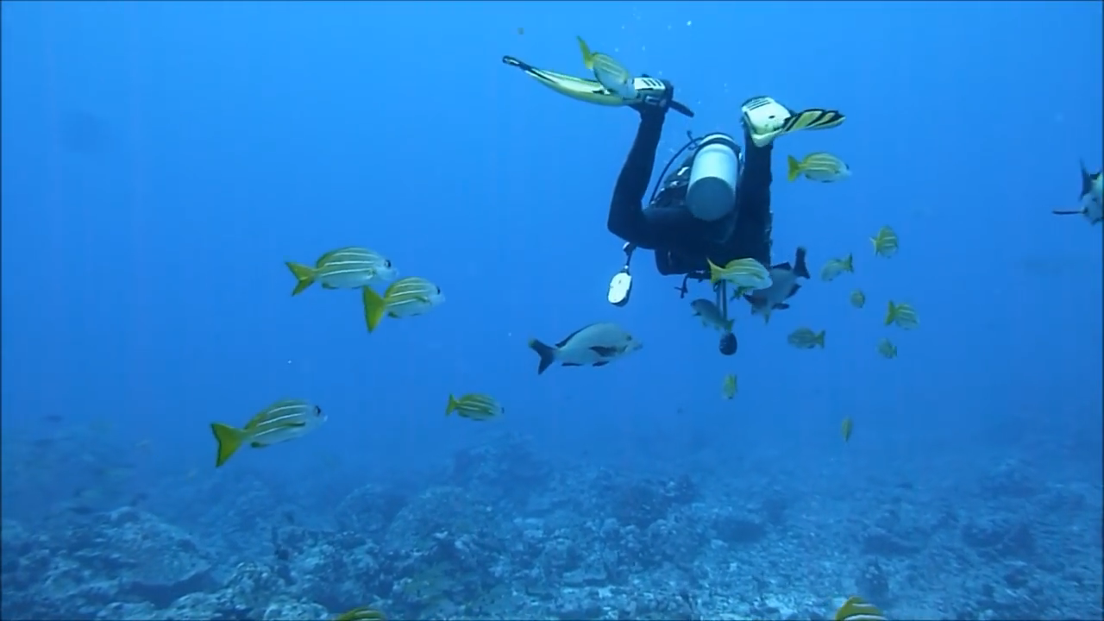 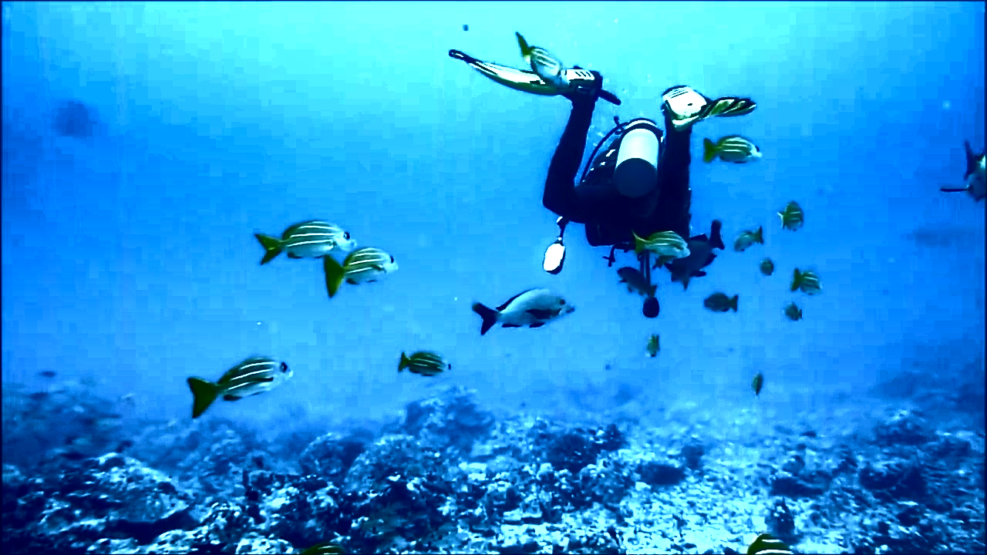 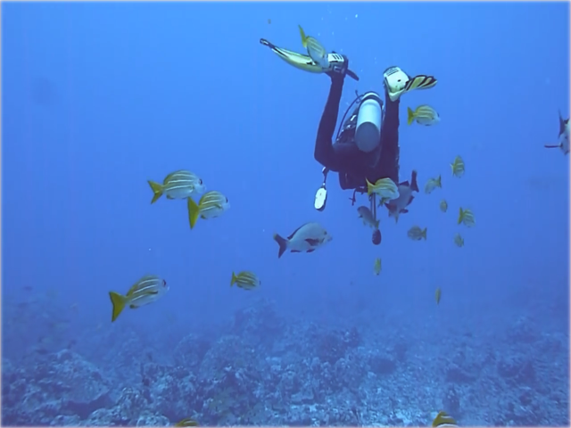 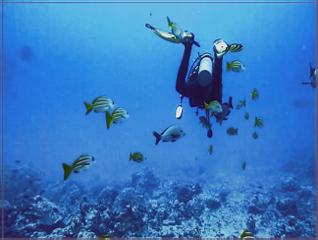

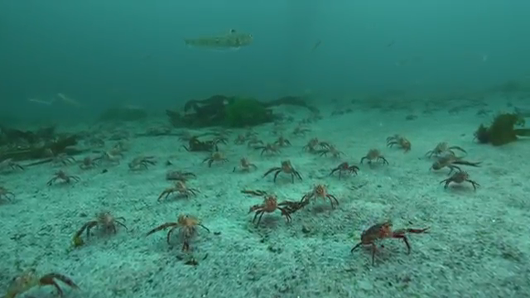 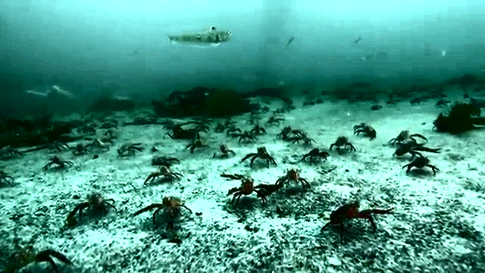 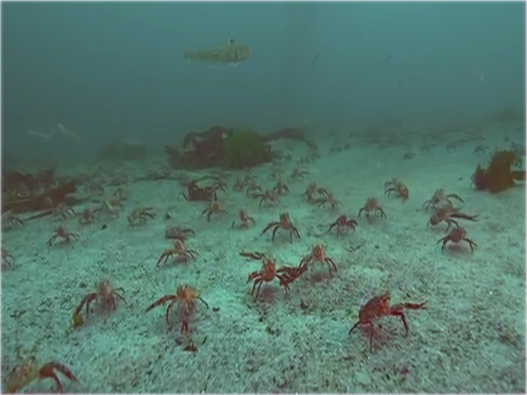 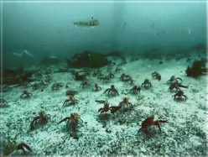

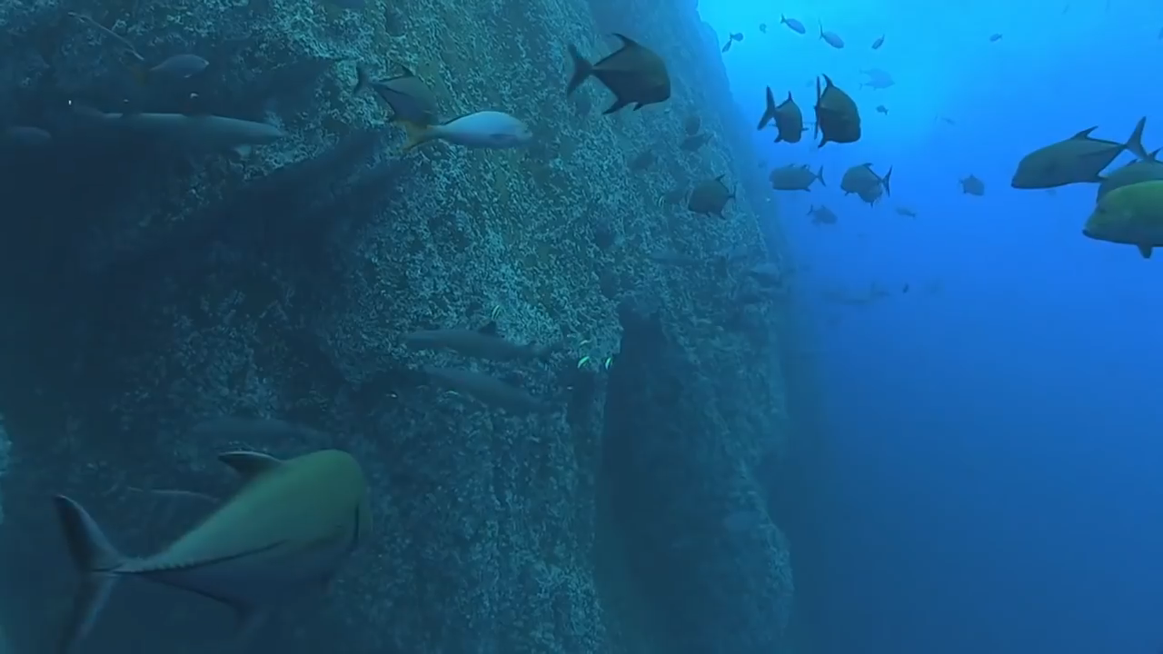 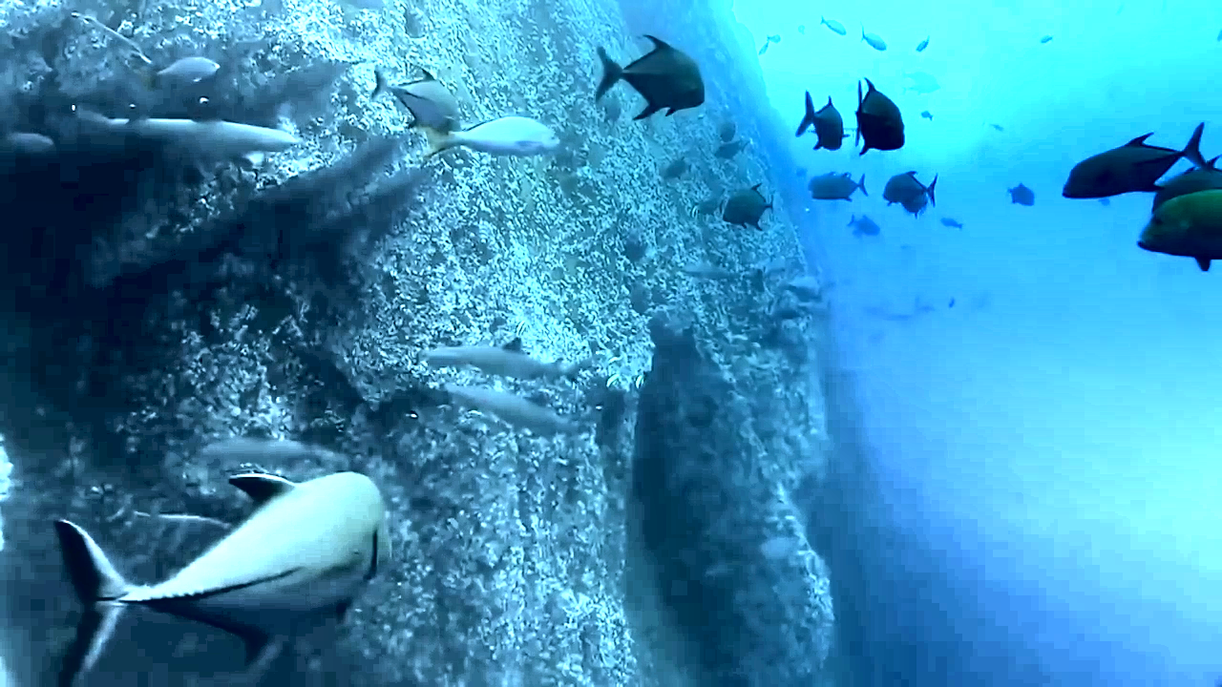 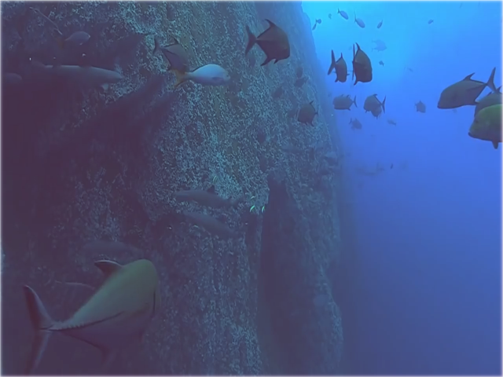 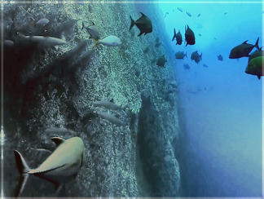

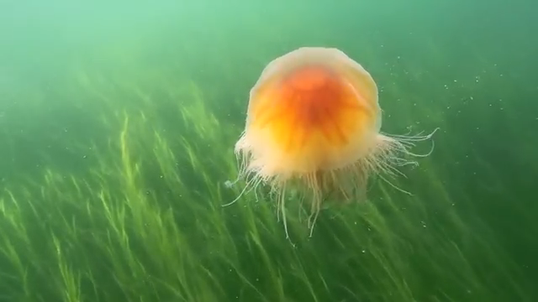 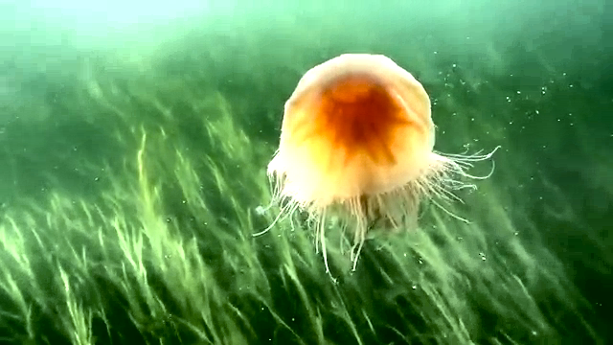 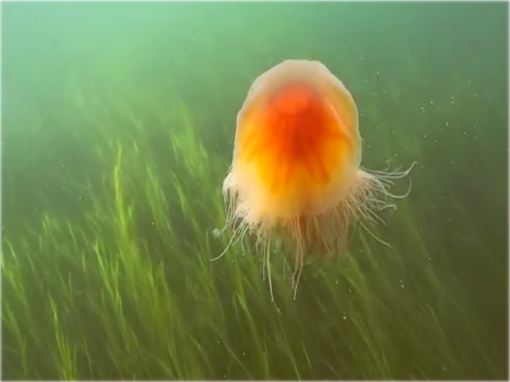 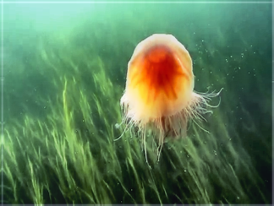

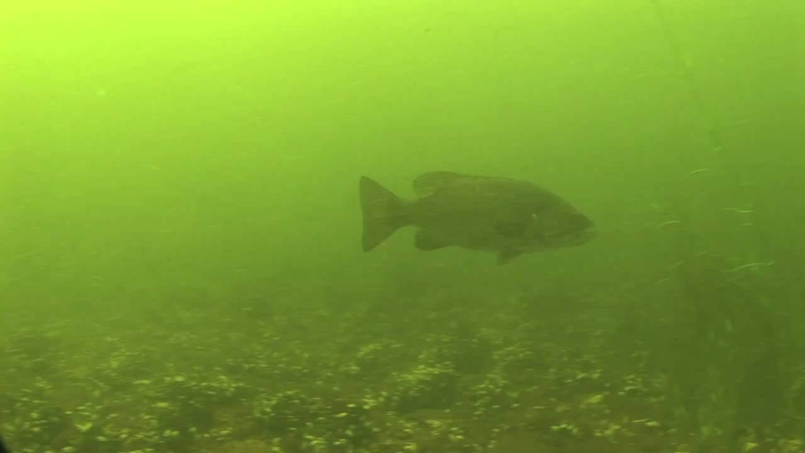 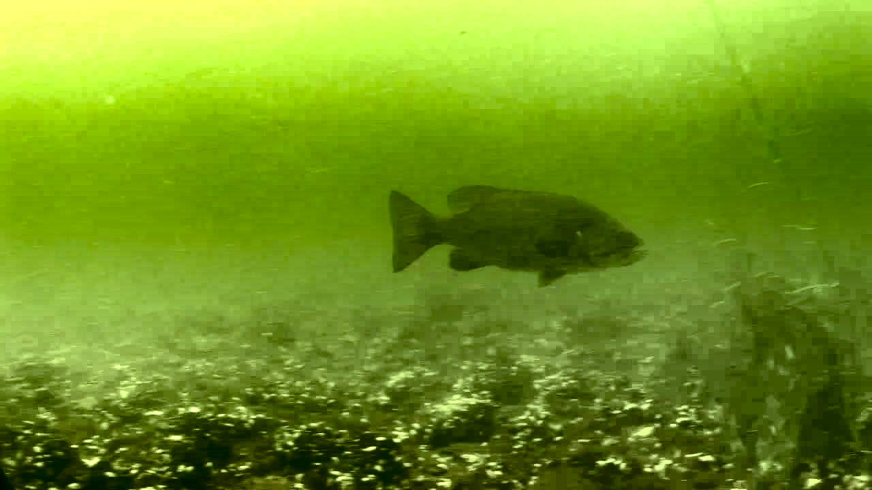 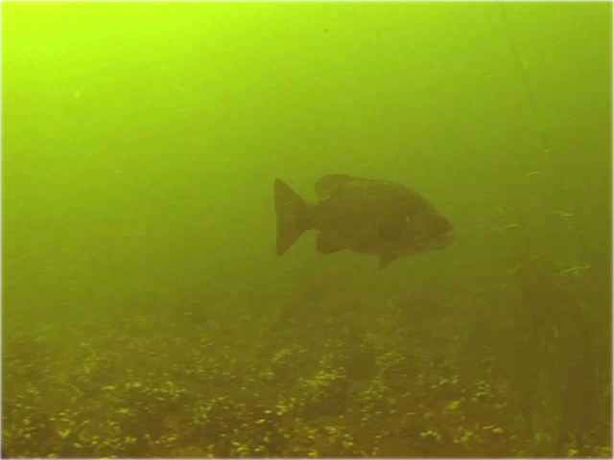 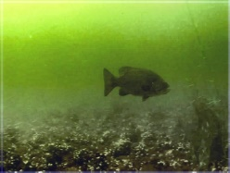

**Fig 2: a) Original Image, b) Contrast & Illumination Corrected image, c) Dehazed Image, d) Fused Image**

1. **CONCLUSION**

This paper analyzed how fusion techniques are used to improve the quality of underwater images. One of the biggest problems that underwater images face is the Haziness of the images, the presence of a material heavier than air accounts to the diffusion of light; which in turn accounts for distorted/ hazy images. CNN model is one of the best models for Image haziness reduction, since it constitutes of the learning of machine in order to detect and remove the haziness from the images. Popular technologies are also used including CLAHE, which is an improved version of Adaptive Histogram Equalization and optimized for higher accuracy and contrast limiting. Arithmetic translations are also used for areas of illumination correction, wherein the Gamma correction values are used to increase the illumination of an image. Lastly DWT fusion technique is used because it is known for its higher quality image fusion as compared to similar techniques of the similar spatial domain. PSNR, SSIM and CCF metrics were used to visualize the quality differences between the images numerically.

1. **REFERENCES**
2. Liu, Yidan, et al. "An underwater image enhancement method for different illumination conditions based on color tone correction and fusion-based descattering." Sensors 19.24 (2019): 5567.
3. Galdran, Adrian, et al. "Fusion-based variational image dehazing." IEEE Signal Processing Letters 24.2 (2016): 151-155.
4. Zhu, Zhiqin, et al. "A novel fast single image dehazing algorithm based on artificial multi exposure image fusion." IEEE Transactions on Instrumentation and Measurement 70 (2020): 1-23.
5. Fu, Xueyang, et al. "A fusion-based enhancing method for weakly illuminated
6. images." *Signal Processing* 129 (2016): 82-96.
7. Sahu, Akanksha, Vikrant Bhateja, and Abhinav Krishn. "Medical image fusion with Laplacian pyramids." *2014 International conference on medical imaging, m-health and emerging communication systems (MedCom)*. IEEE, 2014.
8. Khan, Amjad, et al. "Underwater image enhancement by wavelet based fusion." *2016 IEEE International Conference on Underwater System Technology: Theory and Applications (USYS)*. IEEE, 2016.
9. Parihar, Anil Singh, et al. "A comprehensive analysis of fusion-based image enhancement techniques." *2020 4th International Conference on Intelligent Computing and Control Systems (ICICCS)*. IEEE, 2020.